**Gestion des tickets**

**Réaliser par :**

* **BISSAOUI Yassine**
* **AAMEUR Nouhaila**

1. 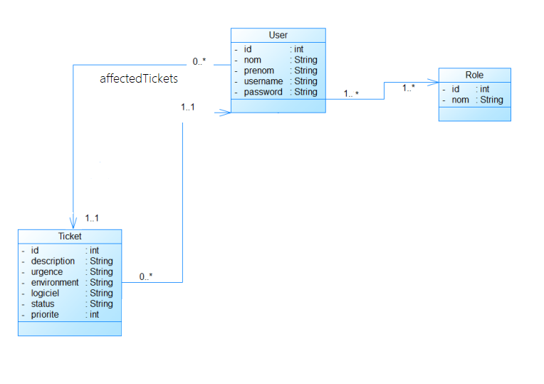**Diagramme de class :**
2. Graphical user interface, application

   Description automatically generated**La liste des fonctionnalités :**

**page de login**

**page d’inscription**

**Client :**

**Page de creation de ticket**

**liste des tickets**

**Details Ticket**

**Admin :**

**Liste des utilisateur**

**Details Utilisateur**

**Liste des Tickets**

**Attribuer ticket**

**Développeur :**

**Liste des tickets**

1. **App_db_connection**

**MYSQL_HOST=mysqldb**

**MYSQL__USER=root**

**MYSQL__PASSWORD=root**

**MYSQL__PORT=3306**

1. **Db_connection**

**MYSQL_ROOT_PASSWORD=root**

**MYSQL_DATABASE=gestionticket**

1. **Lien git**

[**https://github.com/bissaoui/Gestion-Tickets-Bugs-**](https://github.com/bissaoui/Gestion-Tickets-Bugs-)